7th November 2018

Dear Parent / Carer,

We will be having Christmas Dinner again in school and all pupils are welcome to have a dinner. If your child usually has a packed lunch they are welcome to have the Christmas Dinner. The cost will be £2.20 but we will need to know by Friday 16th November so that we can order supplies.

If you could ring the school office to inform us we would be very grateful.

Yours sincerely

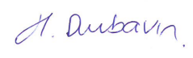

Helen Dunbavin
Headteacher

