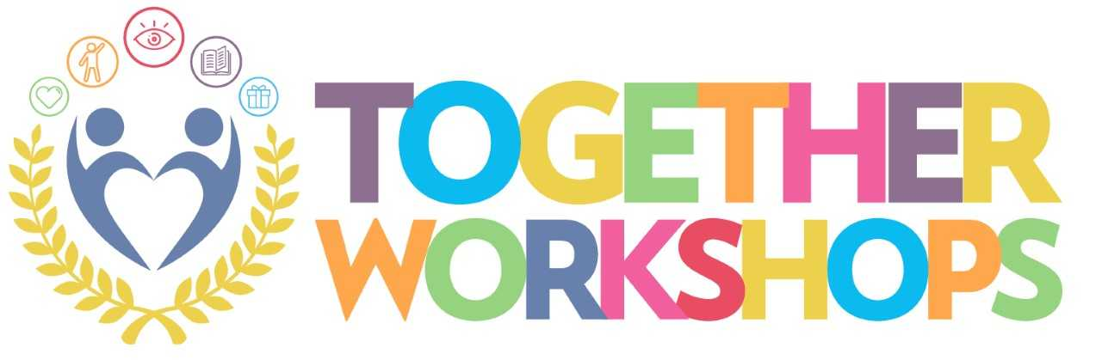
Struggling to understand your child’s mental health?
Do you feel as though you need support?
Birchwood can help!
Our Together Workshops are designed to support families and professionals of young people aged between 13-18 years, who are experiencing emotional and mental health difficulties, the aim is to help you and your child re-connect whilst developing and sharing experiences, skills and knowledge.
The workshops have been developed as a way forward in preventing hospital admission.
Workshop Aims:
- Build and inspire confidence in managing things when times are tough
- Increase awareness of wellbeing tools
- Develop and share skills
- Provide a supportive, empathetic and understanding environment
We want families and professionals who are supporting their young people to feel well equipped to manage their mental health in a positive forward-thinking way.
Tell us how you feel….
You don’t understand
Please contact:
Charlotte Simpson or Linda Tuck
on
01695 728391
Alternatively, email
charlotte.simpson@wlcrisiscentre.org.uk

