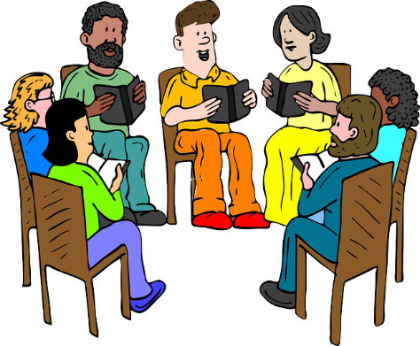

Hope High School Council
Date: |  |  | Time:

Agenda
1: charity run, cricket ball throw, hit the ball with the bat. Own clothes day. (3 events) need to pick the charity. Someway of supporting children. Cake sale and juice.
2: New rule: football only to be played on the MUGGER.
3: re-look at the dispatch trip, make sure it is even.
4: not enough variation of food, need changes.
5:

6:
7:
8:

