**Your Flight Plans Explained**

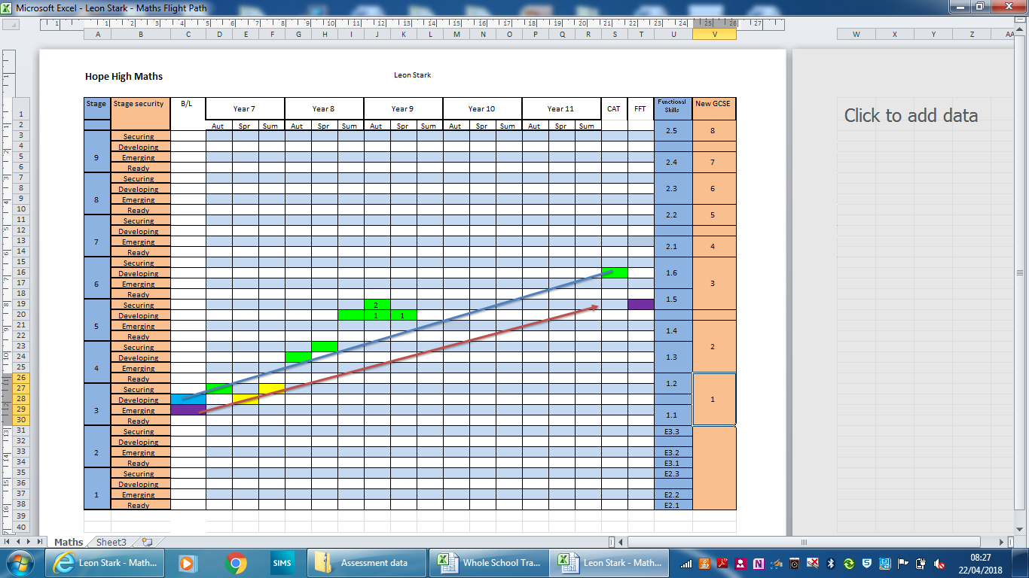

If you maintain progress along the red line, you will achieve the result in the purple square.

FFT 50 Prediction.

Functional Skills Result Prediction

KS2 SAT Result Baseline

School Baseline

CAT Test Prediction

Academic Year

If you maintain progress along the blue line, you will achieve the result in the green square.

CAT Prediction.

GCSE Result Prediction

FFT (SAT) Prediction

Term

Sub Stage