**Your Flight Plans Explained**

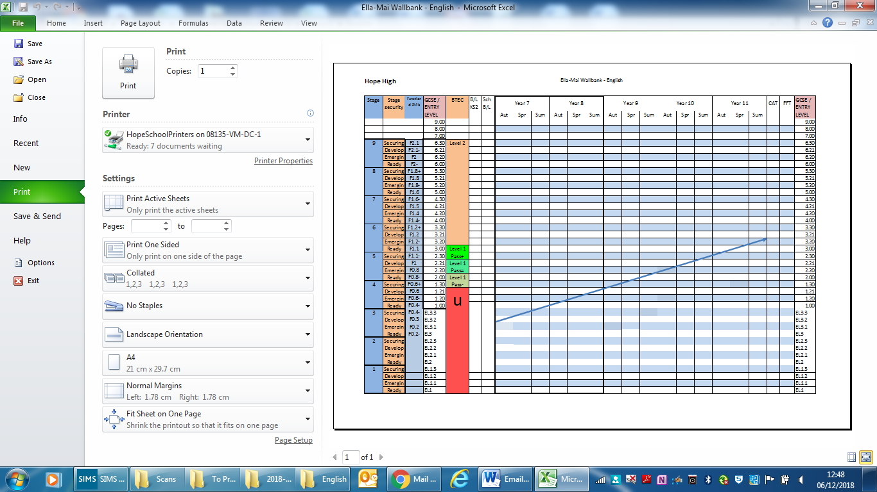

Pupils are expected to maintain progress against this line.

Functional Skills Result Prediction

School Baseline

Academic Year

If you maintain progress along the blue line, you will achieve the result at the end of the line in year 11

GCSE Result Prediction

FFT (SAT) Prediction

Term

Sub Stage